2.3 The Present Perfect tense

Contents

2.3.1 The Present Perfect Simple

2.3.2 The Present Perfect Continuous Tense

Guiding questions
- Which two times does the Present Perfect tense connect?
- Why are these tenses called Present Perfect if they can refer to actions happening in the past?
- What is the difference between the perfect and the perfect continuous aspect?
- When do we use for and when since with the Present Perfect tense?

Before you start studying this unit, we recommend that you read 2.1 (Aspects).

2.3.1 The Present Perfect Simple

Affirmative
subject | auxiliary | verb (past participle)
I  You  We  You  They | have | been | here before.
He/she/it | has

Negative
subject | auxiliary | not | verb (past participle)
I  You  We  You  They | have | not | been | here yet.
He/she/it | has

Interrogative
(question word) | auxiliary | subject | verb (past participle)
(How many times) | have | I  you  we  you  they | been | here before?
 | has | he/she/it

This tense connects the present and the past time.

2.3.1.1

It is used for actions in the past the exact times of which are not known or not important.

I’ve been to China.

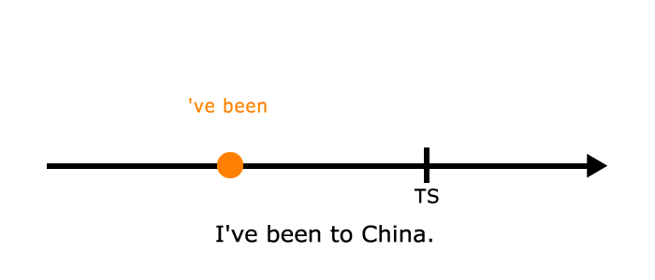

I’ve been to China.

Note that in such a sentence we use the preposition to instead of in. Also note that if we mention when this happened, we will have to use the Past Simple tense (cf. 2.2.1.1). In this case, however, the preposition in is used.

I was in China in March 1989.

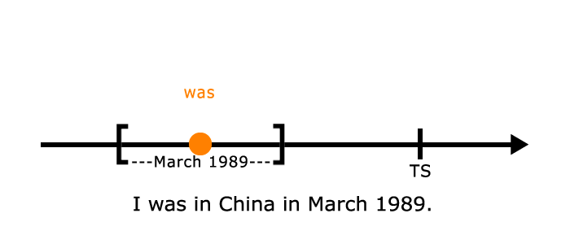

We also use the Past Simple if we ask when something happened in the past.

“Have you ever been to China?”

“Yes, I have.”

“When did you go there?”

But:

When have you ever done the dishes?

This sentence does not refer to a specific time and implies criticism.

2.3.1.2

The Present Perfect is used for recent actions that have a result in or an effect on the present.

Someone has opened the window.

Here we want to emphasise that the window is open. The sentence infers that it is probably cold inside.

Someone opened the window.

This sentence simply states a fact. Whether the window is open or not is not important. The focus is on the action, not the result or the effect of that action.

2.3.1.3

This tense is also used for recently completed actions, usually with the word just.

I’ve just bought a processor. My computer needed to be upgraded.

I have just started a typing course.

However, when the exact time is mentioned we use the Past Simple. (Cf. 2.2.1.1)

I bought this processor two weeks ago. My computer needed to be upgraded.

Just now also requires the use of Past Simple and means “a moment ago”. (Cf. 2.2.1.4)

I spoke to him just now. He says hi.

2.3.1.4

The Present Perfect is used to express actions happening in an incomplete period. An incomplete period is one which includes the present moment, that is, the time of speaking. For example, the time expressions today, this week, this year, in my life, etc. all refer to such a period.

I haven’t smoked today.

I’ve lived here all my life.

Have you ever been to China? (the implied incomplete period here is “your life”)

My brother has written several plays. (in his life, which is incomplete as he is still alive)

I have never driven such a fast car.

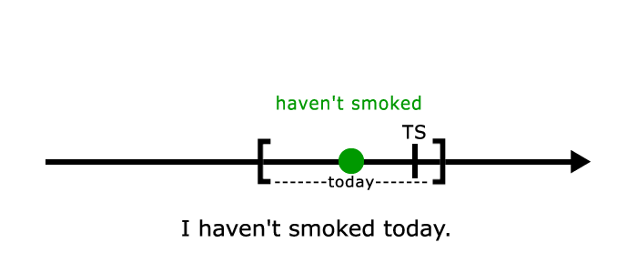

If we mean a completed period, which does not contain the time of speaking, we cannot use the Present Perfect. Instead the Past Simple is used. (Cf. 2.2.1.3)

I lived in this house when I was a child. (I am not a child any more.)

Did you go to China when you worked as a flight attendant?

Shakespeare wrote several plays. (in his life, which is completed as he is dead now)

He worked in this café between 1905 and 1906.

I didn’t smoke yesterday.

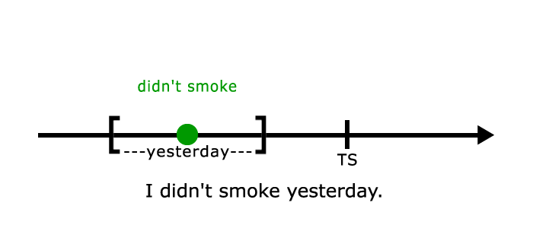

Note that some time expressions (e.g. this morning, recently, lately) can refer to either a completed or an incomplete period depending on the context and whether the time of speaking is included or not in the given period.

I have seen him this morning.

I saw him this morning.

The first sentence suggests that it is still “this morning”, so the time of speaking is before approximately 1 p.m. The second sentence is said later during the day.

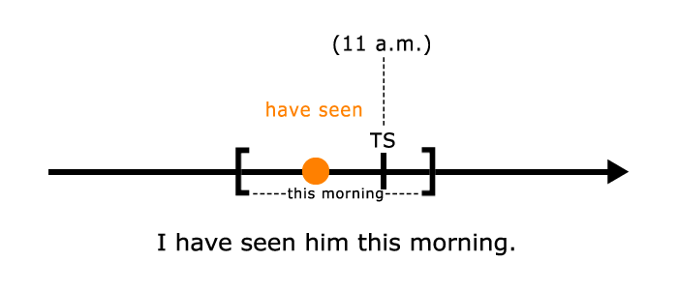

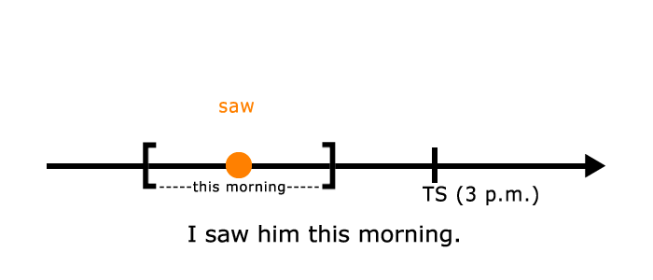

Compare these two sentences also.

He has put on a lot of weight recently.

He gained some weight recently.

In the first sentence recently means in the past few days/weeks/months etc, which period includes the time of speaking, while in the second sentence it expresses some time ago, which refers to a point in time in the past.

NOTE

Note that we do not always use the Present Perfect even if we mean an incomplete period of time.

Have you been to Lake Balaton this year?

In this sentence we are merely curious if he has visited the place any time during this year. (indefinite time, incomplete period)

Did you go to Lake Balaton this year?

In this case, however, I know that my friend goes to Lake Balaton every year, usually around the same time. What we ask is whether he went there this year (at that time) as well. Here we mean a definite time in an incomplete period.

Have you been to Lake Balaton this year?
Did you go to Lake Balaton this year?

2.3.1.5

The prepositions for and since are often used with the Present Perfect. For is used with a period of time, while since refers to a point in time.

I have lived here for two months. (period)

I have lived here since January. (point in time)

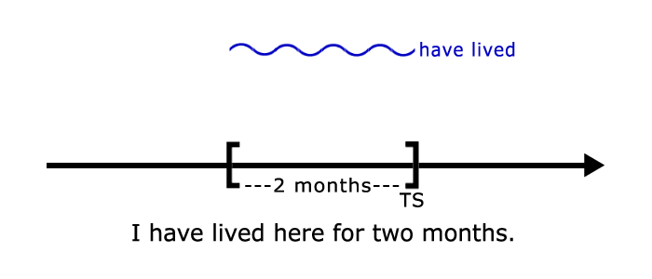

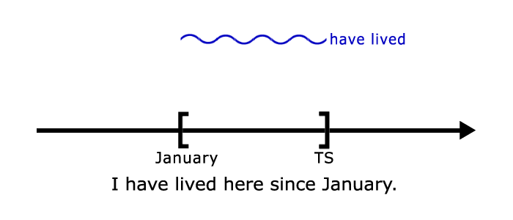

For questions we use how long? and since when?

“How long have you lived here?”

“For ten years.” (Or “Since 2002.”)

“Since when have you lived here?”

“(Since) 2002.”

NOTE

But since when + Present Simple in questions is used to express annoyance:

Since when can people like Geoffrey join this club?!

The point in time after since can also be expressed with a time clause, in which the Past Simple is used (cf. 2.3.1.1).

I have lived here since I was born.

NOTE

For can also be used with the Past Simple to refer to a period of time. However, in this case this period is completed (cf. 2.2.1.3).

I lived here for two months. (I don’t live here any more.)

In this case if we put a question about the length of the period, we say:

How long did you live here?

2.3.1.6

The Present Perfect is also often used with superlative forms of adjectives to express emphasis.

This is the first time I have been to Prague.

This is the worst film I have ever seen.

This use also applies to the Past Perfect tense. (Cf. 2.2.3.2)

Jill was the most beautiful girl John had ever met.

This sentence means that until that time John had never met such a beautiful girl. It also implies that he has since then. If, however, poor John hasn’t met anybody like her since then, we use the Present Perfect:

Jill was the most beautiful girl John has ever met.

With future tenses (this will be…) we use the Simple Present in such structures.

This will be the last time that I buy you a tram ticket.

2.3.1.7

If we want to emphasise the length of time that has passed since a past event, an introductory it is used with the Present Perfect tense.

It has been years since I last met him.

How long has it been since you met him?

In everyday speech, however, it is more common to use the Present Simple instead of the Present Perfect.

It’s years since I last met him.

How long is it since you met him?

2.3.2 The Present Perfect Continuous Tense

Affirmative
subject | auxiliary |  | verb (present participle)
I  You  We  You  They | have | been | lying | here for hours.
He/she/it | has

Negative
subject | auxiliary₁ | not | auxiliary₂ | verb (present participle)
I  You  We  You  They | have | not | been | working | for 2 weeks.
He/she/it | has

Interrogative
(question word) | auxiliary₁ | subject | auxiliary₂ | verb (present participle)
(Why) | have | I  you  we  you  they | been | lying | here all day?
 | has | he/she/it

The Present Perfect Continuous tense also connects the present and the past time but with a greater emphasis on the duration of the action.

2.3.2.1

For actions which started in the past and are still in progress in the present or have just finished.

I’ve been waiting for you for ages.

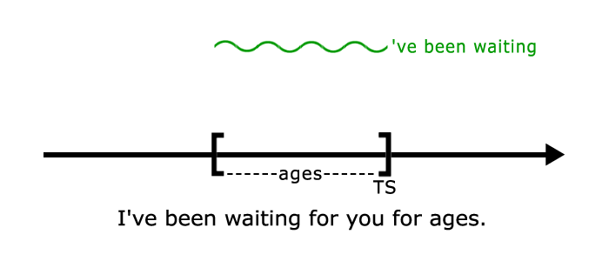

I’ve been waiting for ages.

This use is similar to that which we mentioned in 2.3.1.5 above with the Present Perfect.

2.3.2.2

In contrast with the Present Perfect Simple tense, which emphasises the result of a completed action, the Present Perfect Continuous tense focuses on the duration or the activity itself. For example:

I have written two letters today. (result)

I’ve been writing this letter all week. (duration or activity)

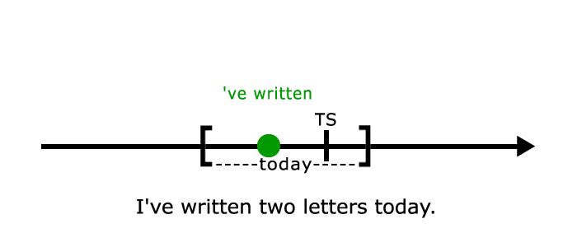

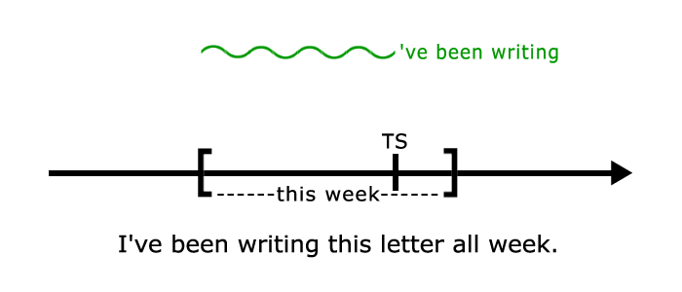

The same difference exists between these two sentences:

What have you done?

What have you been doing?

The first one refers to one action that has a result in the present (a broken vase, a bleeding nose, etc.). The second sentence could be rephrased as How have you spent the past minutes/hours?

2.3.2.3

Another difference between these two tenses is that the Present Perfect Simple might refer to a habitual action over an incomplete period (She has always worked hard.), while the Present Perfect Continuous can be used for habitual, repeated actions over an incomplete period (She has been getting up at 6 for the last two weeks.).

Note that if the Present Perfect Simple is used for an action which started in the past and is still in progress in the present (cf. 2.3.2.1), a time expression is needed, while the Present Perfect Continuous can be used with or without such an expression.

I’ve waited for you for an hour.

I’ve been waiting for you for an hour.

I’ve been waiting for you.

Revision questions
- What is the difference between the sentences He wrote ten novels and He has written ten novels?
- What do we mean by an incomplete period?
- Can we use the Past Simple for an action happening in an incomplete period?
- Which tense is used with the time expression just now?
- What is the difference between these two sentences: I have called him today and I’ve been calling him all day?

